Assignment 1

DSP for Computer Science

- In the previous lecture, we briefly discussed whole and half sample symmetric signals. A whole sample symmetric signal as described in the lecture is a signal that is symmetric about the sample at 0 and satisfies the equation x(n)=x(-n). Can you write a similar equation for a half sample symmetric sequence?
- Any signal (continuous or discrete) can be represented in terms of an odd and an even function. Thus
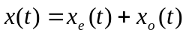
Determine x_{e}(t) and x_{o}(t).
- Using MATLAB or any programming language of your choice, plot the following: The input signal is 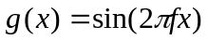. Assuming a sampling frequency of 100 units, plot the graphs for g(x) for 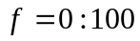 in steps of 10. Plot the first 100 samples of g(x) for each frequency. Answer the following questions:
  - What is the period (in samples) of each of the sampled sinusoids?
  - What is the relation between sinusoids on either side of 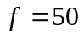? Can you give a mathematical explanation for this?

